Results of the 2022/2023 Quality of Life Survey:
KEY FINDINGS
Community Life & Social Determinants
Survey results show a high level of engagement in the community and a perception that the West Mountain Region is a good place to live. In general, higher-income households and White residents tend to be more engaged. 17.4% of community members consider their housing situation unstable and 18.4% report feeling food insecurity. 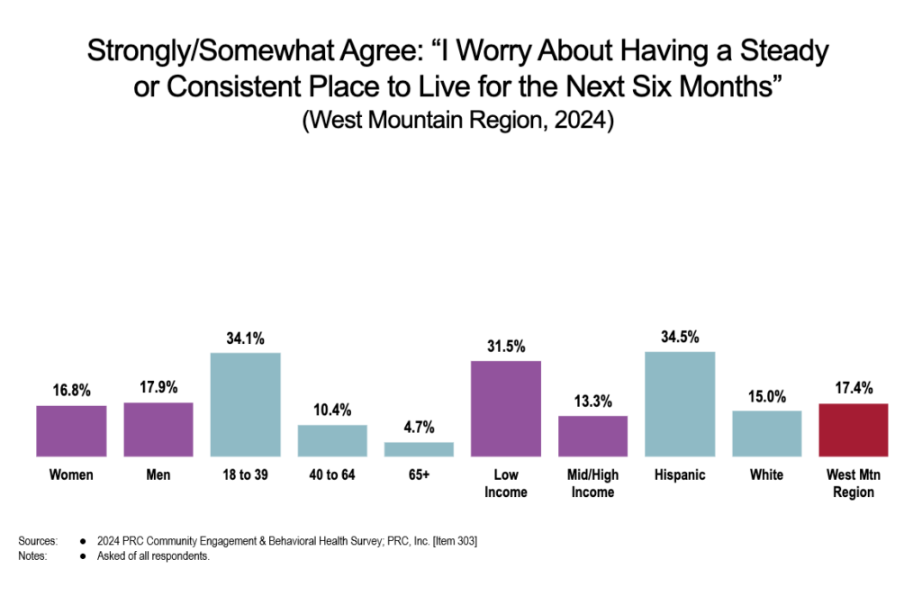

Social Support
4 out of 10 adults reported feeling lonely, lacking companionship, feeling left out, and/or feeling isolated from others.
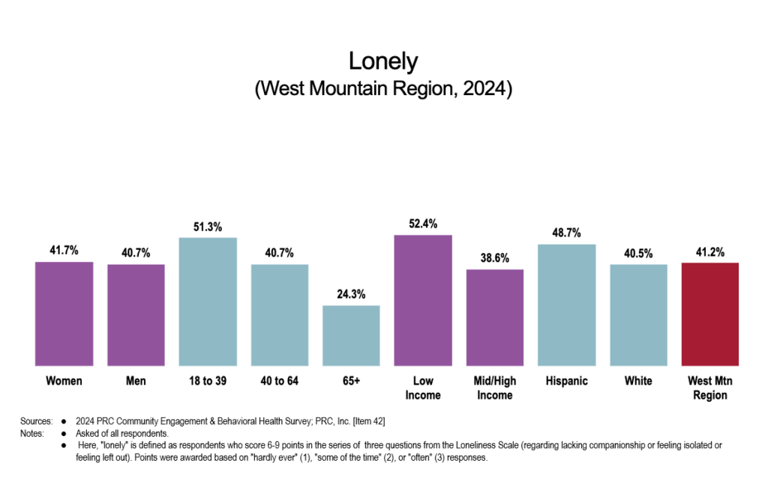

Mental Health
While many residents believe our community is sympathetic to those with mental health concerns, fewer feel it is easy to openly discuss issues related to mental health. A high number of poor mental health days (three or more days per month during which mental health is not good) were reported. Many community members are aware of resources, however, Hispanic residents and adults aged 40-64 are less likely to seek services. Access to services still appears to be a barrier due to cost, insurance access, lack of availability, & more. 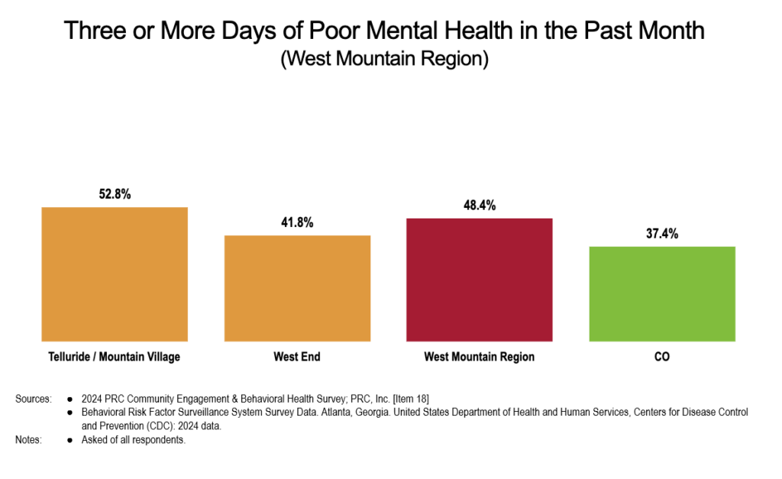

Substance Use
Alcohol is strongly associated with social life in our community, with 8 out of 10 respondents (higher among White respondents) agreeing it is important to most people’s social lives. Binge drinking rates are higher than the national average with 40% of residents engaging in excessive drinking. Additionally, the impact of substance use is felt across the region with 75% of survey answerers stating their own life has been negatively affected by someone’s substance use (either their own or someone close to them).
